**Map Algorithms**

**Creating Area Property**

- Area Shape is Circle Shape Only

- Current location will become the central point of the circle shape

- Getting radius value of circle depends on the user input of valid range distance for viewing file, encryption and decryption Files: The range will be between 10m and 1,000m

- Valid area will include until value on circumference of the circle.

**Basic Map Algorithms**

1. Get the current Location value from Google Map API

2. Check the value whether it is inside of the areas by referencing the database table.

3.1 **IF** there is no valid areas in database table, **THEN** create new area with range depends on user decision.

3.2. **ELSE IF** there are some valid areas with the value, **THEN** show the valid areas option list. And the last option is Create new area. This case also is depends on the user decision.

**Scenarios**

1. Each part of area between two areas is overlapped case

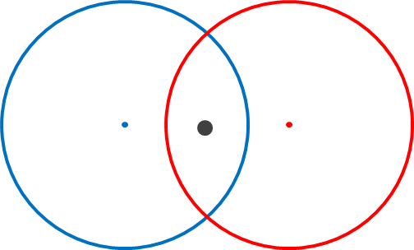 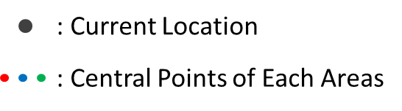

2. A part of circumference, or Arc, between two areas meets in one point case

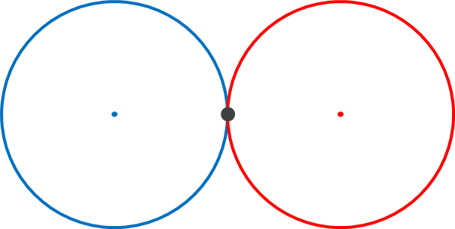 

3. Each part of area among multiple areas (at least 3 areas) is overlapped case

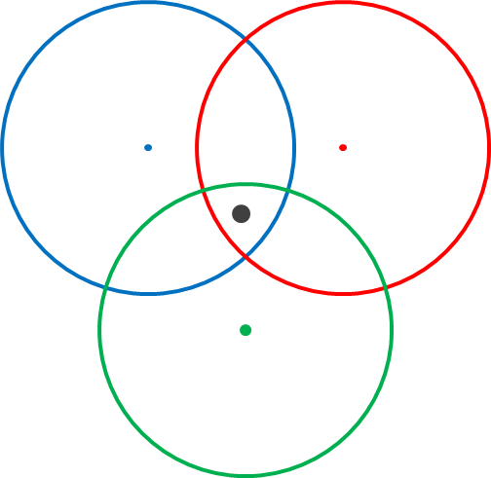 

4. One wide range of area includes the whole small range of area case

